14.Perform Perspective Transformation on the given image using python and Open CV.

**AIM:**

To perform Perspective Transformation on a given image using Python and OpenCV.

**PROCEDURE:**

1. Install OpenCV if not already installed using:

2. Import the cv2 and numpy modules.

3. Read the input image using cv2.imread().

4. Define four points from the original image (source points) and their corresponding positions in the transformed image (destination points).

5. Compute the **Perspective Transformation matrix** using cv2.getPerspectiveTransform().

6. Apply the transformation using cv2.warpPerspective().

7. Display the original and transformed images using cv2.imshow().

8. Save the transformed image using cv2.imwrite(), if needed.

9. Wait for a key press and close all image windows using cv2.waitKey(0) and cv2.destroyAllWindows().

**PROGRAM:**

import cv2

import numpy as np

image = cv2.imread("image.jpg") # Replace with your image file path

rows, cols, ch = image.shape

pts1 = np.float32([[50, 50], [400, 50], [50, 400], [400, 400]])

pts2 = np.float32([[10, 100], [300, 50], [100, 300], [350, 350]])

matrix = cv2.getPerspectiveTransform(pts1, pts2)

transformed_image = cv2.warpPerspective(image, matrix, (cols, rows))

cv2.imshow("Original Image", image)

cv2.imshow("Perspective Transformed Image", transformed_image)

cv2.imwrite("perspective_transformed.jpg", transformed_image)

cv2.waitKey(0)

cv2.destroyAllWindows()

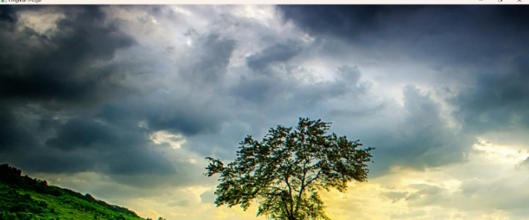**INPUT:**

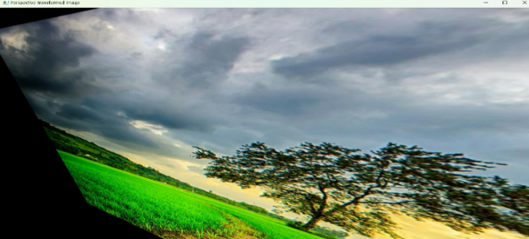 **OUTPUT:**

**RESULT :**

The program successfully applies a **Perspective Transformation** to the given image, displays it, and saves it as "perspective_transformed.jpg".